**Visvesvaraya Technological University**

# Belagavi, Karnataka-590 014



A Mini Project Report on

“**EVALUATION OF CARDIOVASCULAR PARAMETERS USING PPG**”

**Submitted By**

**Adway Uday Kanhere - 1MS16ML001**

**Jigyans K M - 1MS16ML022**

**Prajna G Hardikar- 1MS16ML034**

**T H Greeshma- 1MS16ML053**

**Under the guidance of**

**Dr N.Sriraam & Mrs.Prabhu Ravikala Vittal**

**Department of Medical Electronics, RIT.**



**Ramaiah Institute of Technology, Bangalore 560054**

**Department of Medical Electronics**

**2018-19**

**RAMAIAH INSTITUTE OF TECHNOLOGY,**

**BANGALORE- 560054**

**Department of Medical Electronics**

**CERTIFICATE**

Certified that the Mini project work entitled " **EVALUATION OF CARDIOVASCULAR PARAMETERS USING PPG**" carried out by Mr. Adway Uday Kanhere (USN:1MS16ML001), Mr. Jigyans K M (USN:1MS16ML022), Ms. Prajna G Hardikar (USN:1MS16ML034) and Ms. T H Greeshma (USN:1MS16ML053) are the bonafide students of Ramaiah Institute of Technology. It is certified that all corrections/suggestions indicated for Internal Assessment have been incorporated in the Report. The project report has been approved as it satisfies the academic requirements in respect of final Project work.

**Dr. N. Sriraam Mrs.Prabhu Ravikala V Dr. N. Sriraam Dr NVR Naidu**

Supervisor Co-Supervisor Head of Department Principal

External Viva

Examiner Signature with date:

1.

2.

**DECLARATION**

We, the students of pre-final semester of Medical Electronics, Ramaiah Institute of Technology, Bangalore-560054 declare that the work entitled " **EVALUATION OF CARDIOVASCULAR PARAMETERS USING PPG** " has been successfully completed under the guidance of **Dr. N. Sriraam and Mrs. Prabhu Ravikala Vittal** Medical Electronics Department, Ramaiah Institute of Technology, Bangalore. Further the matter embodied in the project report has not been submitted previously by anybody.

Place:

Date:

Team members:

1. Adway Uday Kanhere 1MS16ML001
2. Jigyans K M 1MS16ML022
3. Prajna G Hardikar 1MS16ML034
4. T H Greeshma 1MS16ML053

# **Table of Contents**

# 1. **Chapter-1** **Introduction 9**

# 1.1 Importance of PPG in Clinical Diagnosis 9

# 1.2 Need for Proposed Study 10

# 1.3 Specific Objective 10

# 1.4 Outline of the Project 10

## **2. Chapter-2 Related Background 12**

# 2.1 Literature Table 12

# 2.2 Gap Analysis 14

## **3. Chapter-3 Proposed Pulser System for Recognition of Cardiovascular Variation. 15**

# 3.1 Proposed System 15

# 3.2 Study Design 18

## **4. Chapter-4 Performance Evaluation 32**

## 4.1 Pre-Processing 32

# 4.2 Feature Extraction 34

# 4.3 Analysis and Inference 46

# 4.4 Statistical Analysis 46

## **5. Chapter-5 Performance Evaluation 59**

## 5.1 Conclusion and Future Works 59

# 5.2 References 62

# **LIST OF FIGURES**

Figure 1.1: Components of PPG Waveform

Figure 1.2: Project Roadmap

Figure 3.1: Block Diagram of PULSER

Figure 3.2: Sensor with Microcontroller Unit

Figure 3.3: First Prototype Sensor Enclosure

Figure 3.4: Final Prototype Sensor Enclosure

Figure 3.5: Data Acquisition Setup

Figure 3.6: Finger Based PPG Acquisition Setup

Figure 3.7: Wrist Based PPG Acquisition Setup

Figure 3.8: Carotid Based PPG Acquisition Setup

Figure 3.9: Timing Diagram

Figure 3.10: Algorithm

Figure 4.1: Raw PPG Signal

Figure 4.2: Pre-processed PPG Waveform

Figure 4.3: Peak Detected PPG Plot

Figure 4.4: Plot of BPM for Male and Female

Figure 4.5: Plot of SDSD for Male and Female

Figure 4.6: Plot of SDNN for Male and Female

Figure 4.7: Plot of IBI for Male and Female

Figure 4.8: High Frequency Plot for Male and Female

Figure 4.9: Plot of pNN50 for Male and Female

Figure 4.10: Plot of pNN20 for Male and Female

Figure 4.11: Plot of RMSSD for Male and Female

Figure 4.12: Original and Interpolated Waveform

Figure 4.13: Frequency Spectrum of HRV Parameter

Figure 4.14: First and Second Derivative Plot for Male under the age of 25 years

Figure 4.15: First and Second Derivative Plot for Male over the age of 50 years

Figure 4.16: First and Second Derivative Plot for Diabetic Male

Figure 4.17: First and Second Derivative Plot for Female under the age of 25 years

Figure 4.18: First and Second Derivative Plot for Female over the age of 50 years

Figure 4.19: First and Second Derivative Plot for Diabetic Female

Figure 4.20: Box Plot for SDNN

Figure 4.21: Box Plot for SDSD

Figure 4.22: Box Plot for PNN20

Figure 4.23: Box Plot for PNN50

Figure 4.24: Box Plot for IBI

Figure 4.25: Box Plot for BPM

Figure 4.26: Box Plot for RMSSD

Figure 4.27.1: Anova for BPM

Figure 4.27.2: T Test BPM

Figure 4.28: Anova for HF

Figure 4.29.1: Anova for IBI

Figure 4.29.2: T Test for IBI

Figure 4.30.1: Anova for RMSSD

Figure 4.30.2: T Test for RMSSD

Figure 4.31.1: Anova for SDNN

Figure 4.31.2: T Test for SDNN

Figure 4.32.1: Anova for SDSD

Figure 4.32.2: T Test for SDSD

Figure 4.33.1: Anova for PNN20

Figure 4.33.2: T Test for PNN20

Figure 4.34.1: Anova for PNN50

Figure 4.34.2: T Test for PNN50

Figure 5.1: Incorrectly labelled R peaks

Figure 5.2: Missed Peaks

Figure 5.3: Incorrectly Reject Peaks

# **ABSTRACT**

This project deals with Photoplethysmography (PPG) which reflects many physiological parameters like heart function, blood vessel elasticity, blood viscosity and so on. It is a non-invasive method with an advantage of convenience and accuracy as an early prognostic tool. The project involves design of a multifunctional enclosure for MAX30101 Evaluation kit. The sensor enclosure enables data collection from fingertip, wrist and carotid artery. Acquisition of PPG signal from subjects of different age groups in resting position and activity. Acquired signal is pre-processed using High pass filter and moving average for removal of baseline drift and noise reduction. The signal is segmented for a window size of five seconds. Various features such as BPM, IBI, SDNN, SDSD, RMSSD, PNN20, PNN50, Low and High frequency components are extracted and evaluated. The feature are extracted by means of a fully automated feature extractor.

# **ACKNOWLEDGEMENT**

We take immense pleasure in thanking Dr.N.Sriraam, Professor and HOD, Department of Medical Electronics, for inspiring us and giving us an opportunity to work on this project.

We express our sincere gratitude and heartfelt appreciation to our project supervisor, Dr.N.Sriraam, Professor and HOD, Department of Medical Electronics, and co supervisor Mrs.Prabhu Ravikala Vittal , Associate Professor, Department of Medical Electronics, for providing us with continuous support and guidance to proceed in the right direction whenever we were stuck in any stage of the project phase. We also like to thank them for their blessings and constant motivation.

We thank Dr.V.S. Prakash and Dr.Sarthak, Ramaiah Memorial Hospital for their comments that greatly helped for the project.

We also thank Mr. Rama Reddy, for sharing his pearls of wisdom with us during the course of the project.

We express our gratitude to Department of Biotechnology for funding the project.

Finally, we express our eternal gratitude to our parents and friends for their motivation and support throughout.

 Adway Uday Kanhere - 1MS16ML001

Jigyans K M - 1MS16ML022

Prajna G Hardikar 1MS16ML034

T H Greeshma- 1MS16ML053

# Chapter 1

# **Introduction**

Photoplethysmography (PPG) is an optical method of measuring blood volume changes in the body. It is often used non-invasively to make measurements at the skin surface. Photo means Light, Plethysmo means change in volume, Gram means graph. So, PPG (Photoplethysmography) means high precision light sensor used to detect volume of blood flow to understand the fluctuation in heart rate.

The PPG waveform comprises of a pulsatile AC component which attributes to the blood volume changes with each heartbeat. It also comprises of a slowly varying DC baseline component on which the AC component is superimposed.

The waveform comprises of three main parts i.e. Systolic peak, Dicrotic notch, Diastolic peak.

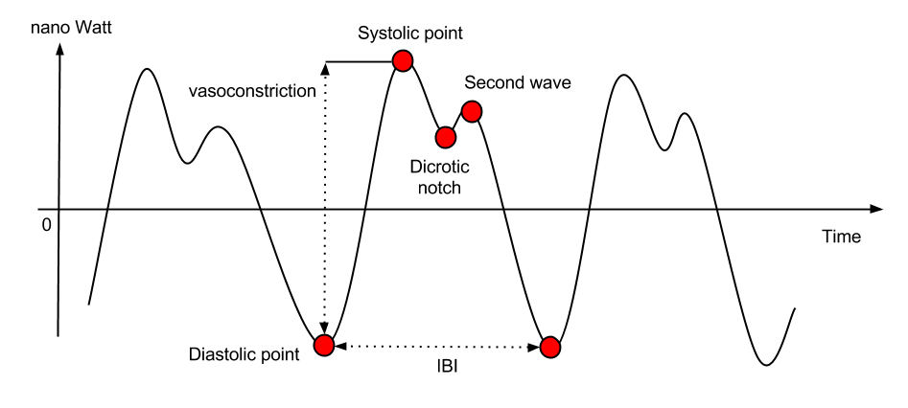

(Figure 0‑1.1)

The PPG signals provide valuable information about the cardiovascular system. When the heart beats, capillaries expand and contract based on blood volume changes. PPG optical sensor, utilizing motion-tolerant technology, emits light signals that reflect onto the skin to accurately and continuously measure weak blood flow signals. The heart pumps the blood through artery to different parts of the body which creates a pressure pulse. The change in volume caused by the pressure pulse is detected by illuminating the skin with a light emitting diode. Light is then attenuated in a manner proportional to the volume of blood present in the artery. Therefore, voltage signal from PPG is proportional to the quantity of blood flowing through the blood vessels. The transmitted or reflected light is then measured by means of a photodiode.

A PPG signal contributes to volumetric changes in arterial blood which is associated with cardiac activity, variations in venous blood volume which modulates the PPG signal, a DC component showing the tissues optical property and subtle energy changes in the body.

Principle of PPG

• PPG makes uses of low-intensity infrared green (IR) light. When light travels through biological tissues it is absorbed by bones, skin pigments and both venous and arterial blood.

• Since light is more strongly absorbed by blood than the surrounding tissues, the changes in blood flow can be detected by PPG sensors as changes in the intensity of light

• The voltage signal from PPG is proportional to the quantity of blood flowing through the blood vessels. Even small changes in blood volume can be detected using this method, providing higher precision.

## Importance of PPG in Clinical Diagnosis

PPG is a simple, low cost and non-invasive optical technique for measurement of blood volume changes at skin surface. Traditionally ECG (Electrocardiography) sensors are used for Heart rate and rhythm detection. Since ECG sensor are bulky, they cannot be used to detect heart rate when body is motion. That’s when PPG is used. Photoplethysmography (PPG) is used to make small wearable heart rate sensors. PPG sensor are compact in size and still provide near perfect result to that of ECG sensor. This helps to accurately and continuously measure heart rate and heart rate variability even during extreme physical activity. Being Compact in size PPG has made it breeze, bringing complex heart rate measuring technique to palms of mankind. There has been a resurgence of interest in the technique driven by the demand for low cost, simple and portable technology for the primary care and community based clinical settings, the wide availability of low cost and small semiconductor components, and the advancement of computer-based pulse wave analysis techniques. It is used in a wide range of commercially available medical devices for measuring oxygen saturation, blood pressure and cardiac output, assessing autonomic function and also detecting peripheral vascular disease. It is used in monitoring heart rate and cardiac cycle. It is also used in monitoring respiration by varying the intrapleural pressure i.e., the pressure between the thoracic wall and the lungs. It keeps a track of depth of anesthesia by generating an immediate response in the amplitude of the PPG through sympathetic nervous system response. PPG has been widely used in clinical physiological monitoring, vascular assessment and autonomic function.

## Need for Proposed Study

* The traditional use of ECG for clinical prognosis hampers the reliability of PPG. Hence, it is not reliable for prognosis.
* Acquisition of biomedical signal from other methods are complicated which in turn affects the comfort of the subject.
* Early warning of Cardiovascular diseases like Coronary artery disease, heart attack, abnormal heart rhythms, arrhythmias and heart valve disease.
* Evaluation of High Sensitivity Pulse oximeter and Heart rate MAX30101 sensor

## Specific Objective

* Study and evaluation of High Sensitivity Pulse oximeter and Heart rate MAX30101 sensor
* Design of a multi-functional enclosure for MAX30101 Evaluation kit.
* Acquisition of PPG signal from finger, wrist and carotid artery.
* Design of an algorithm for feature extraction and further analysis using PPG

## Outline of the Project

### 

(Figure 1.2)

Model Design

* Designing of the sensor and microcontroller enclosure in suitable 3D modeling software. The software used was Fusion 360
* Fabrication of the Sensor Enclosure using Rapid Prototyping manufacturing technology. The technology used is 3D Printing using FDM

Data acquisition:

Acquiring PPG data acquisition locations

* Finger based PPG
* Wrist based PPG
* Carotid artery-based PPG

PPG acquisition un specific conditions

* Resting state
* Pre-Exercise
* Post Exercise

Feature extraction and Analysis: Preprocessing of data and extraction of various features.

# Chapter 2

# **Related Background**

## 2.1 Literature Table

|  |  |  |  |
| --- | --- | --- | --- |
| **Author** | **Research paper title** | **Methodology incorporated in paper** | **What we implemented from the paper** |
| J. Moraes et al., (2018) [1] | Advances in Photopletysmography Signal Analysis for Biomedical Applications. | Insight about heart rate variability importance for PPG applications; talks about important HRV parameters and their significance. | Implemented the time and frequency domain parameters like BPM,IBI, SDNN, SDSD, RMSSD, pnn20, pnn50. |
| Yousef, Q et al., (2012) [2] | The Analysis of PPG Morphology: Investigating the Effects of Aging on Arterial Compliance. | Overview of parameters used to determine arterial compliance; defining a protocol for PPG examination and result analysis | Implemented the 1st and 2nd derivatives as a tool to check local maxima and xero crossing as parameters. |
| V. Jeyhani et al., (2015) [3] | Comparison of HRV parameters derived from photoplethysmography and electrocardiography signals. | Importance of HRV parameters and their significance; Pulse wave detection; results for HRV parameters from ppg and its second derivative | Selection of HRV parameters for feature extracton |
| Shaffer F et al., (2017) [4] | An Overview of Heart Rate Variability Metrics and Norms. | Overview of HRV parameters and their clinical significance | Analysis of HRV parameters and determining evaluation metrics. |
| Wickham, Hadley et al., (2014) [5] | Tidy Data. Journal of Statistical Software. | How to setup a tidy data set; rules of keeping a clean database | Storage of PPG signals as one clean, tidy database . |
| Gilman et al., (2009) [6] | Medical Device Design Process. Conference proceedings. | Design protocol for medical devices | Implementation in designing enclosure. |

## 2.2 Gap Analysis

## 

# Chapter 3

# **Proposed Pulser System for Recognition of Cardiovascular Variation.**

## 3.1 Proposed System

### Description

The proposed system consists of the following:

* Sensor (MAX30101)
* Microcontroller Unit (Based on C8051F321 microcontroller)
* Enclosure for the MAX30101 Sensor and Microcontroller Unit.
* Mass Media Storage Device
* Database
* Processing System
* Signal Processing

The Sensor and Microcontroller Unit together make up the MAX30101 evaluation kit.

## Sensor

The sensor used here is a MAX30101 sensor. It includes internal LEDs, photodetectors, optical elements, and low-noise electronics with ambient light rejection. The sensor operates on a single 1.8V power supply and a separate 5.0V power supply for the internal LEDs. Communication is through a standard I2C-compatible interface. The sensor features a variable sampling frequency from 100Hz to 3200Hz on three different wavelengths of light. The intensity of the LEDs can be adjusted by means of adjusting the PWM signal that is given to them. All of these are configurable by means of the I2C communication.

## Microcontroller Unit

The microcontroller unit makes use of an C8051F321. It handles the I2C communication and the serial communication with the mass media storage device. This can be used to set the sampling frequency and the PWM control of the LEDs used in the system. It also supplies power to the sensor unit.

## Mass Media Storage Device

It is a device used to store the recorded PPG signals. Any device to which data can be written by means of USB serial communication and can be retrieved by any means.

## Database

It is a dataset of collective recordings of PPG for various volunteers.

## Processing System

The database is transferred to a device that has the processing power in order to process the data obtained from the sensor.

## Signal Processing

Application of various algorithms and filter in order to obtain features from the raw PPG signal. Parameters obtained

* BPM
* SDSD
* SDNN
* IBI
* High Frequency Component
* PNN50
* PNN20
* RMSSD

## Sensor Enclosure

A custom-built sensor enclosure that offers the following

* Dust protection
* Mechanical Protection
* Ease in data acquisition
* Ability to acquire data from various regions. Example wrist, fingertip and carotid without having to change the enclosure or the sensor itself

## Microcontroller Unit Enclosure

A custom-built Microcontroller Unit enclosure that offers the following

* Dust protection
* Mechanical Protection
* Ease in attaching the module on the subject

### Block Diagram of Pulser

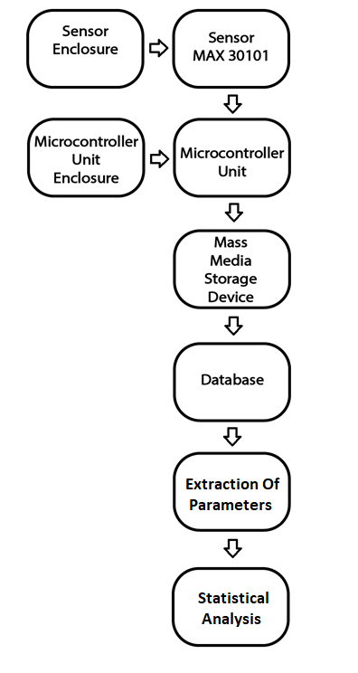

(Figure 3.1)

## 3.2 Study Design

## Enclosure for Sensor Unit and Microcontroller Unit

The enclosures were designed using Autodesk Fusion 360 keeping the following parameters in mind:

* Sensor and microcontroller Unit board dimensions
* Tolerances with respect to the prototyping technology used.

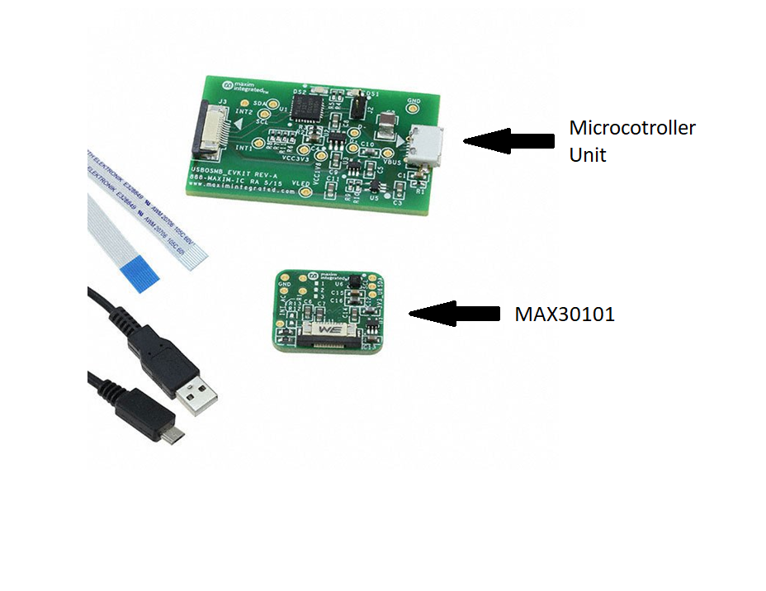

(Figure3.2: The sensor used here is a MAX30101 sensor. It includes internal LEDs, photodetectors, optical elements, and low-noise electronics with ambient light rejection. Sensor communicates with I2C protocol)

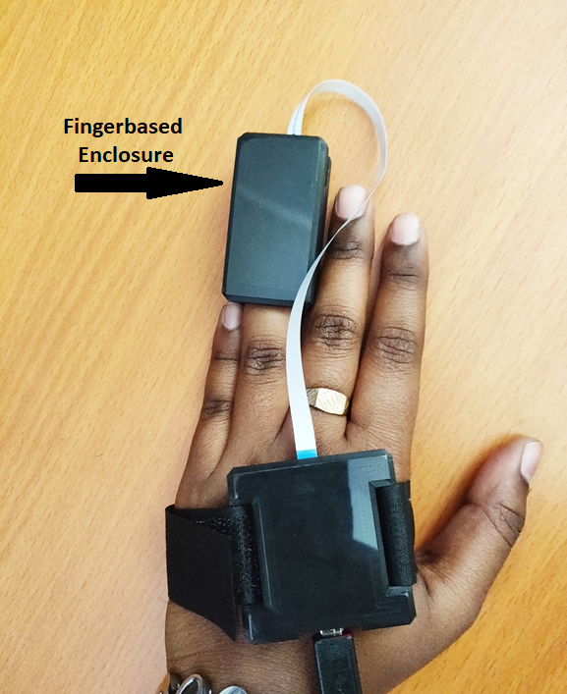

First Prototype

(Figure 3.3: First Prototype Sensor Enclosure: it is an enclosure with incorporated springs for finger-based PPG acquisition. The Microcontroller Unit has Velcro to simplify the signal acquisition process)

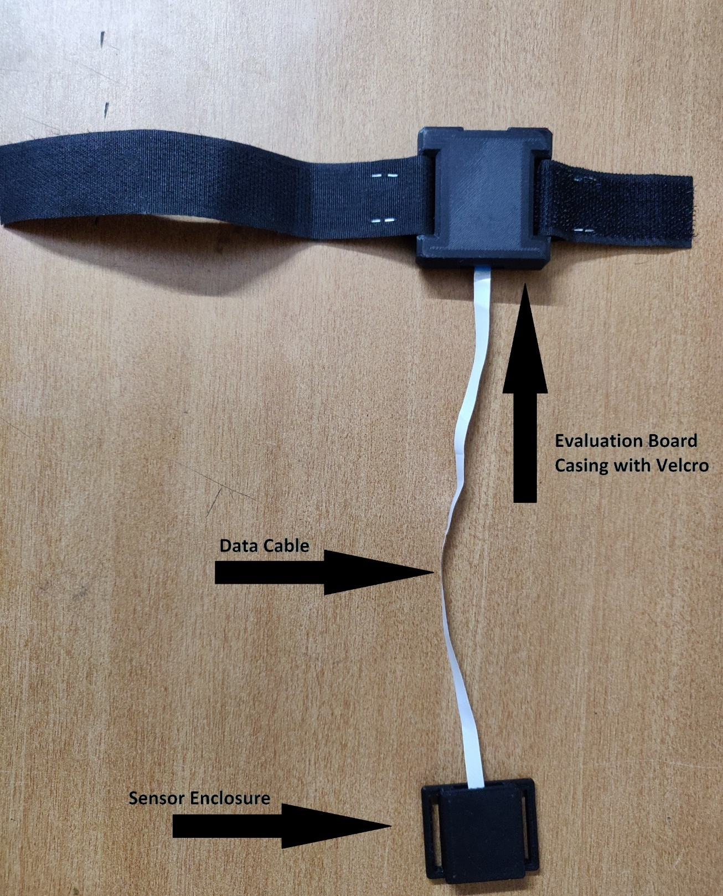

Final Prototype

(Figure 3.4: Final Prototype: Microcontroller Unit with Velcro to enable the enclosure to be strapped on to the body as required. The length of the Velcro may be varied to accommodate the size of the body part to which it is being strapped on to)

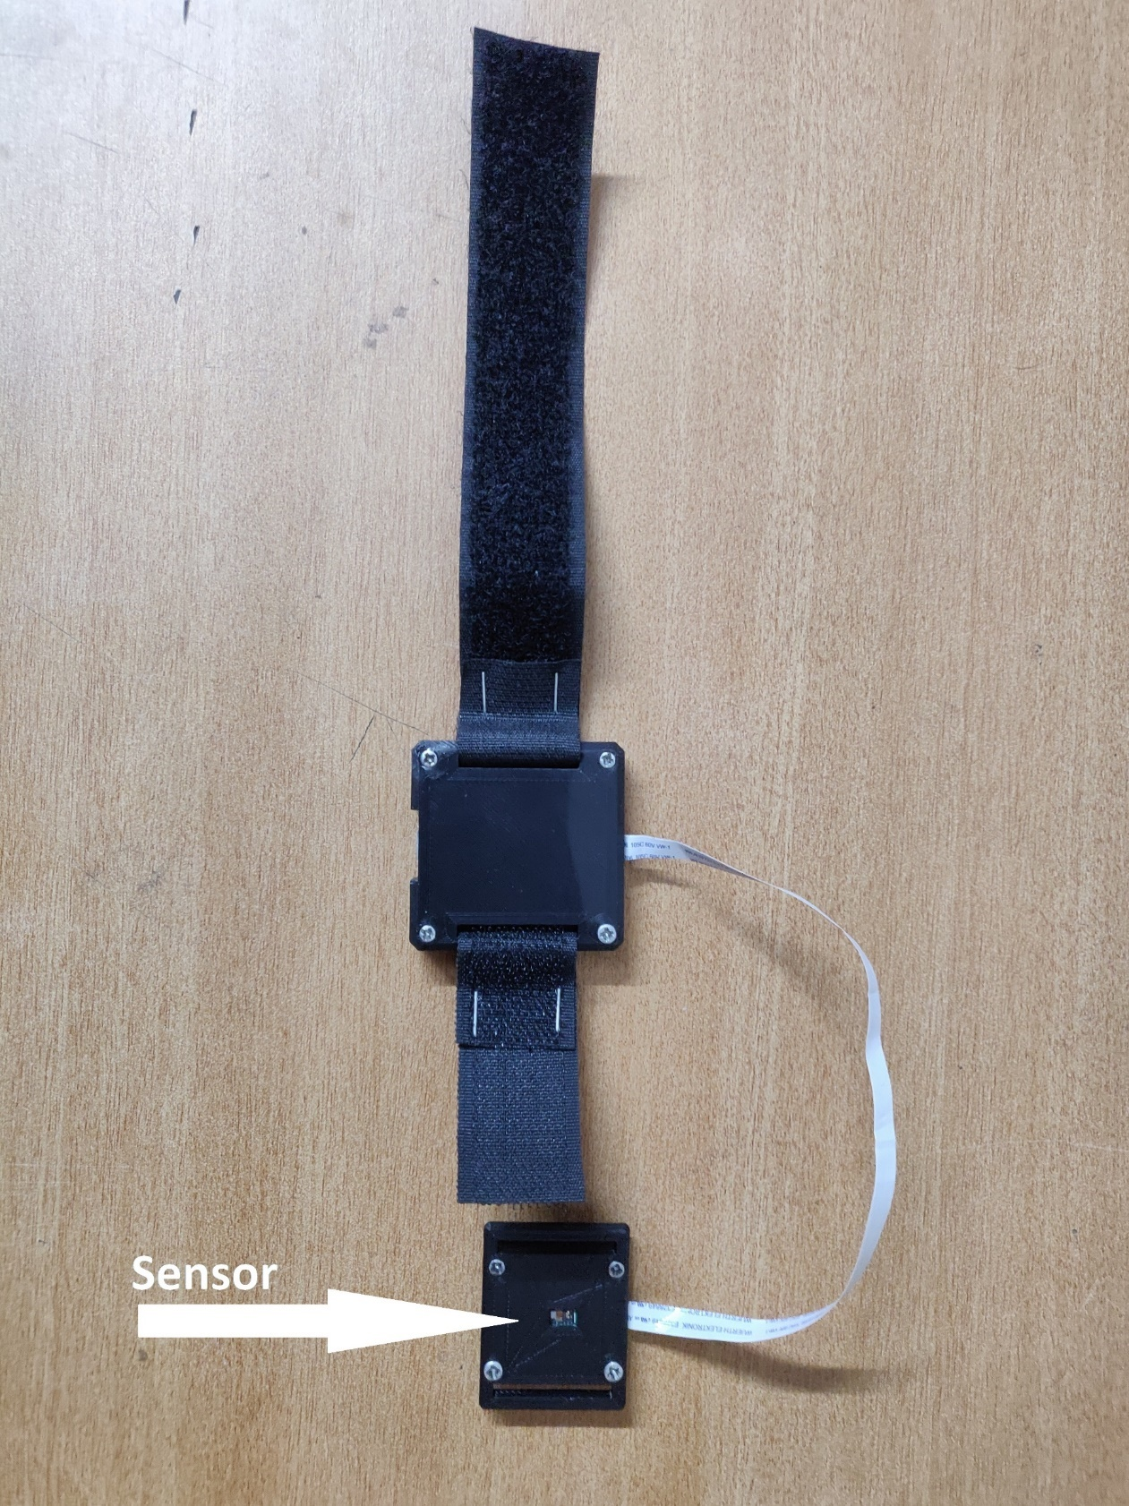

Final Prototype

(Figure 3.5: Final Prototype: Sensor Enclosure was modified to have a compact flat surface to enable signal acquisition from finger, wrist and carotid artery. Furthermore, Velcro may be attached to the sensor module to aid with the data acquisition by preventing need of external mechanical influence)

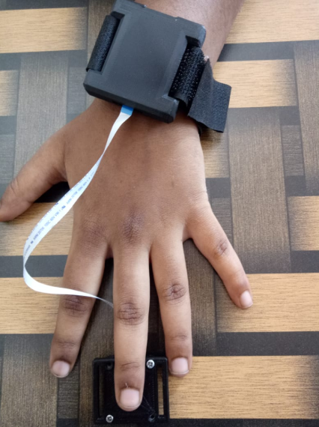

Finger PPG Acquisition

(Figure 3.6: Sensor implementation for finger-based PPG collection. Velcro may be attached to the sensor unit (not shown here))

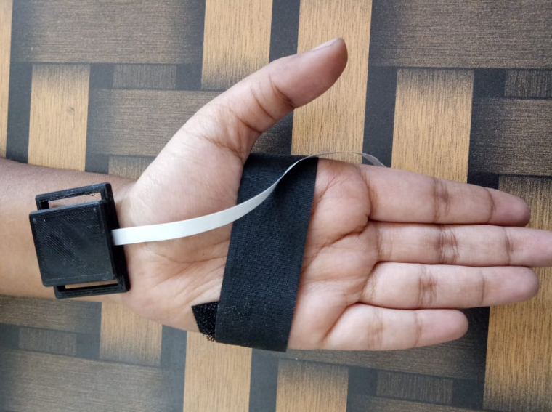

Wrist PPG Acquisition

(Figure 3.7: Sensor implementation for wrist-based PPG collection. Velcro may be attached to the sensor unit (not shown here))

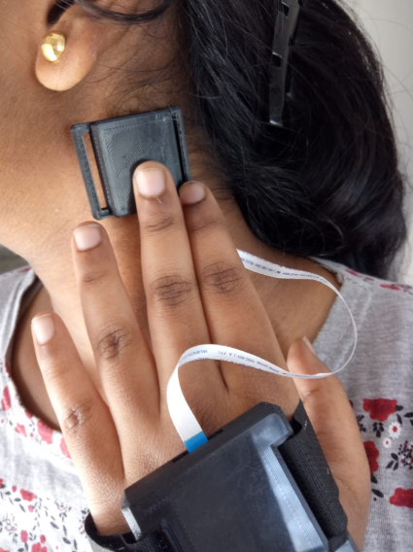

Carotid PPG Acquisition

(Figure 3.8: Sensor implementation for Carotid-based PPG collection. Velcro may be attached to the sensor unit (not shown here))

## Data Collection

Data was collected following the timing diagram given below.

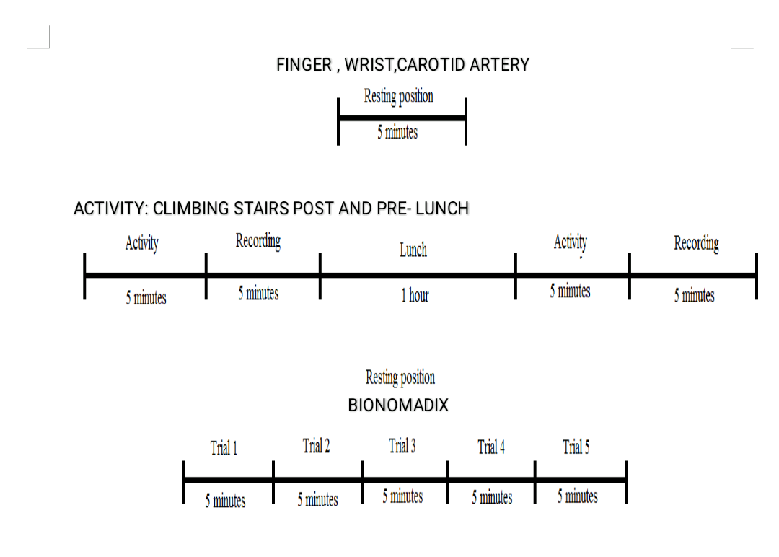

(Figure 3.9: Timing Diagram)

Signal Acquisition from Subjects

MAX30101 Evaluation Kit was used to acquire the biomedical signal, PPG from the concerned subjects. The sampling frequency considered for acquisition was set to 100Hz. The MAX30101 makes use of red, green and IR LED of 660nm ,880nm,527nm respectively. After the preparing the project setup, the subjects were asked to place their finger for finger-based acquisition, wrist for wrist-based acquisition and carotid artery for carotid pulse acquisition on the MAX30101 sensor. Data was acquired from the subjects in resting position for a time period of five minutes. The data is then stored onto a mass media device.

Data was also acquired from the subjects through an activity based. The subjects were requested to climb up and down the stairs before and after the lunch and recording was taken for a time period of five minutes.

Data was also acquired from a Bionomadix system which is a wireless, multichannel physiological recording platform based on the same procedure as followed for the MAX30101 sensor. The recordings were taken for five trails each for a time period of five minutes in a resting position.

A summary of the data collect is given below.

Resting position:

* Male - 62
* Diabetic male - 13
* Total male - 75
* Female - 70
* Diabetic female - 5
* Total female - 75

Wrist: 10

Carotid Pulse: 10

Bionomadix: 20

Activity: Climbing stairs pre-lunch and post lunch

* Male -7
* Female - 7

Total data collected: 204

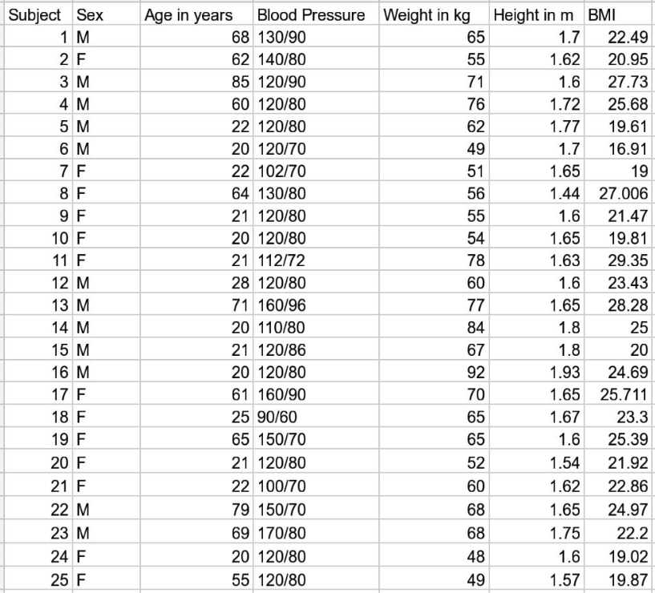

Physiological Parameters of Subjects

## Ethical Clearance

The Project is due approved by M S Ramaiah Hospital and Medical College, Bangalore, India.

# Algorithm

# 

(Figure 3.10: Algorithm)

## Pre-processing

The PPG signal is acquired from the MAX sensor and the data is stored in the form of a table and saved in the database. This signal is now processed using our designed algorithm to derive various heart rate variability parameters. Why choose heart rate variability (HRV)?

Heart rate variability (HRV) analysis is a common practice for assessment of the cardiovascular autonomic nervous system function. The oscillations present in the beat-to-beat intervals of heart rate are of clinical relevance for both diagnostic and prognostic purposes as they are directly influenced by the sympathetic and parasympathetic systems of the body.

HRV seems to be an emergent regulatory system property that can aid in the understanding of adaptation of the body to environmental and physiological changes.

The heart beat is not a metronome and oscillations of the heart are complex and non-linear.

Mathematical modelling of the randomness of the beat-beat fluctuations is necessary and the variability of non-linear systems provides the scope to cope with a changing environment.

Hence an optimum value of HRV can be used as a diagnosis of health and self-regulatory capacity and adaptability of the body to the environment.

The raw sensor data was found to be noisy with signal fluctuations and base line wandering. Motion artifacts were also present in some data.

To remove the baseline wandering, a high pass FIR filter of cut off frequency 5Hz and order 504 was used.

A 16-point moving average filter was used to smoothen the signal and increase signal strength.

This signal output was then used for detection of peaks for HRV parameter calculations.

All the 5-minute recordings are segmented into 5 second windows for easier calculations.

## Feature Extraction

The signal is now detected for R peaks using the algorithm proposed below.

1. The data is scaled for values between 0-1024
2. For determining the R-peaks we define ROI (Region of interest) and find their maxima. We do this by
   1. We draw a moving average and fit it at each point of our signal.
   2. We mark the ROI where the signal is higher than the moving average.
   3. Find the highest peak in each ROI.
3. We use different values of moving average to best describe all the peaks in the signal correctly
4. We define a threshold value for each segment and reject peaks that are too lower or too higher than the thresholds.
5. Finally, we get the locations of all the R peaks in the signal. We further find all the adjacent RR intervals for HRV parameters calculations.
6. We also calculate the BPM (beats per minute) for each segment
7. Now that we have found the RR intervals and R peaks from our signal, we move on to calculate the HRV parameters.
8. For the time domain, we choose the following parameters,

|  |  |
| --- | --- |
| **BPM** (Beats per minute) | R peaks per minute. |
| **IBI** (inter-beat interval): the mean distance of intervals between heartbeats | The RR intervals derived prior. |
| **SDNN**: the standard deviation of intervals between heartbeats |  |
| **SDSD**: the standard deviation of successive differences between adjacent R-R intervals |  |
| **RMSSD**: the root mean square of successive differences between adjacent R-R intervals |  |
| **pNN50**: Proportion of differences greater than 50ms | RR > 50 ms |
| **pNN20**: Proportion of differences greater than 20ms | RR > 20 ms |

1. The plots for the parameters for 10 Male and 10 Female individuals are shown.
2. The _M/_F legends are used to denote Male and Female data.

By analysing the plots, we see that the plots for RMSSD, SDNN, SDSD, pNN50 show significant thresholds for Males vs Females.

Similarly, The SDNN is the "gold standard" for medical stratification of cardiac risk when recorded over a 24 h period. This can be evaluated for our 5-minute recording as well.

Similarly, for the frequency domain analysis, we calculated the following measures.

|  |  |
| --- | --- |
| LF (Low Frequency) | >0.04 & <0.15 Hz |
| HF (High Frequency) | >0.16 & <0.5 Hz |

In order to perform frequency domain analysis, we had to perform a few more pre-processing techniques,

An FFT (Fast Fourier Transform/ Discrete Fourier Transform) requires evenly spaced signals.

Our R-R intervals are most certainly not evenly spaced in time. This is because the position in time of the intervals is dependent on their length, which is different for each interval.

To perform this we do,

1. Create an evenly spaced timeline with the R-R intervals on it.
2. Resample the signal to create an evenly spaced time series. This is done by interpolating the signal with a cubic spline
3. Transform the signal to the frequency domain.
4. Integrate the area under the LF and HF portion of the spectrum

Apart from the above calculated parameters, the 1st and 2nd order derivatives were also computed for the signals.

* **Maximum first derivative**: Equals the maximum positive pulse gradient, i.e., the maximum rate of upswing of the pulse wave signal corresponding to the peak velocity of the vessel wall. This is determined numerically from the maximum positive value of the first derivative of the pulse wave.
* **Maximum second derivative**: Equals the maximum positive rate of change of the gradient, i.e., the maximum acceleration of the vessel wall. This is determined from the calculation of the maximum positive value of the second derivative of of the pulse wave.

# Chapter 4

# **Performance Evaluation**

# 4.1 Pre-Processing

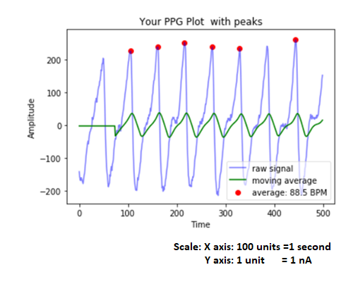 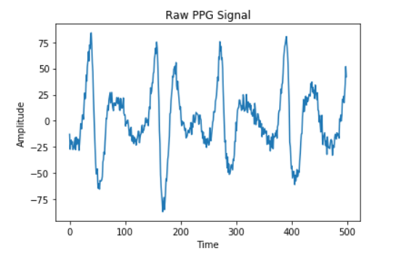

(Figure 4.1: Raw PPG)

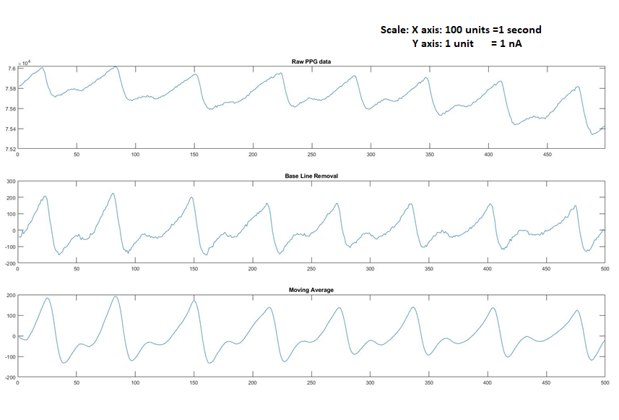

(Figure 4.2*: The figure above at the top shows raw PPG data acquired from the sensor. The plots below show result after baseline wandering removal and application of moving average filter)*

# 4.2 Feature Extraction



(Figure 4.3 :Figure shows the PPG wave with detected peaks using our algorithm)

(Figure 4.4)

(Figure 4.5)

(Figure 4.6)

(Figure 4.7)

(Figure 4.8)

(Figure 4.9)

(Figure 4.10)

(Figure 4.11)

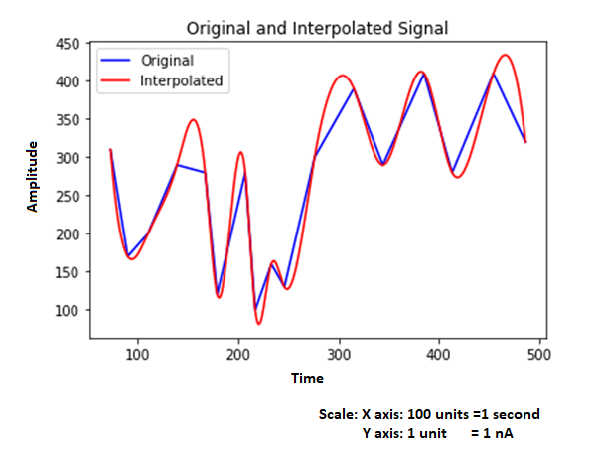

(Figure 4.12: *Figure above shows original signal and the interpolated signal that creates an evenly spaced curve)*

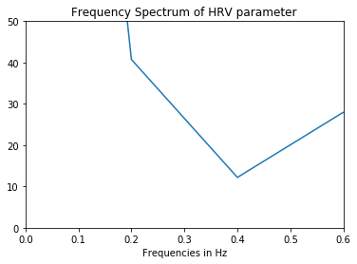

(Figure 4.13: Figure above shows the FFT of the signal)

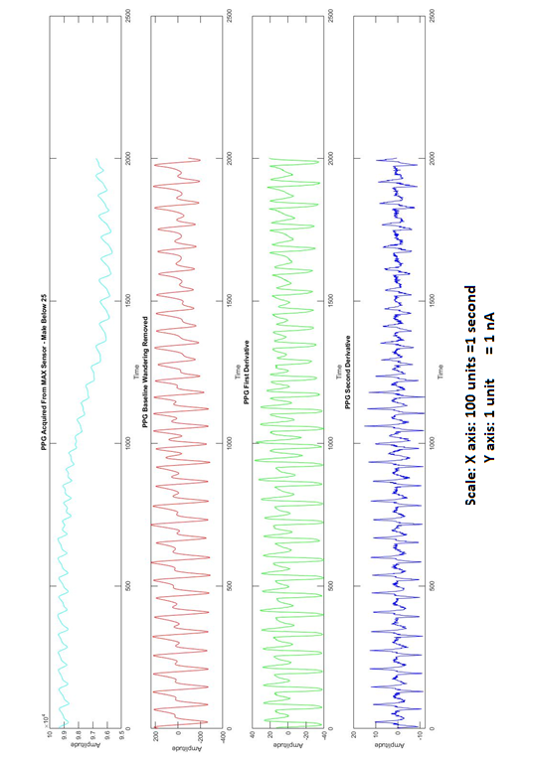

(Figure 4.14: Figure shows plots in green and blue as 1st and 2nd derivative for Male under age of 25 years)

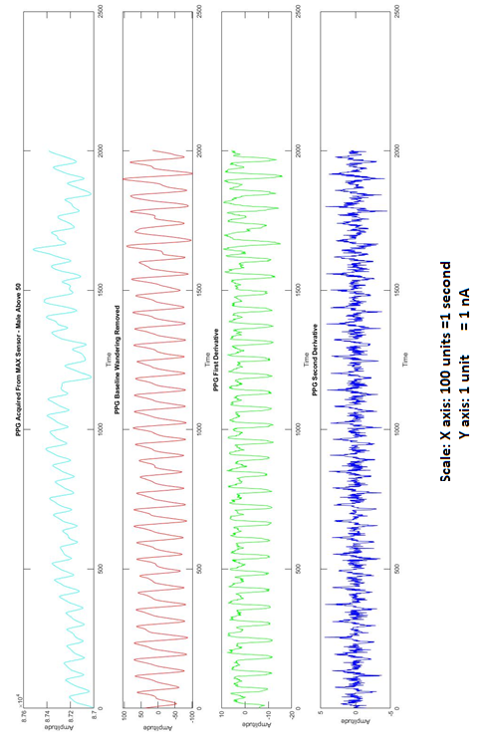

*(Figure 4.15: Figure shows plots in green and blue as 1st and 2nd derivative for Male over**the age of 50 years)*

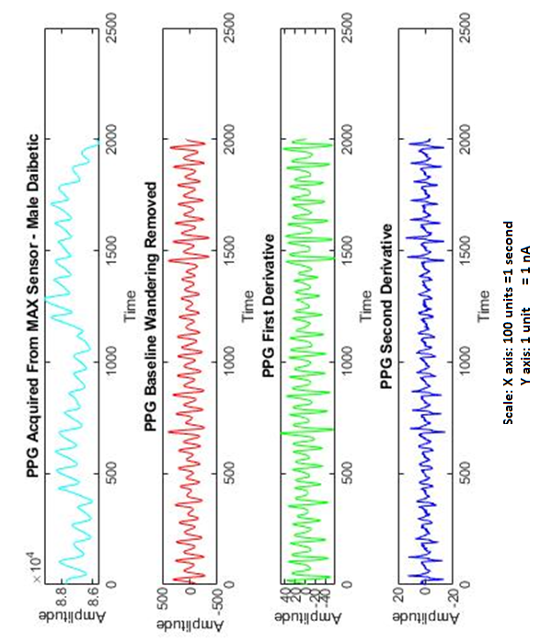

(Figure 4.16: *Figure shows plots in green and blue as 1st and 2nd derivative for Diabetic Male)*

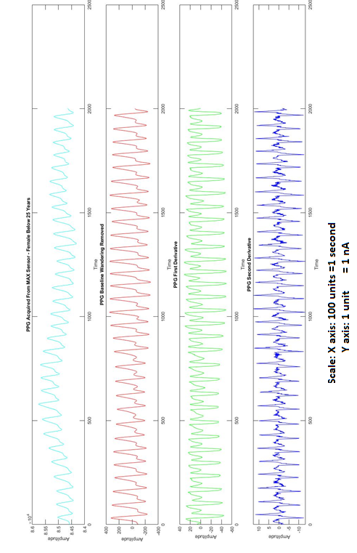

*(Figure 4.17: Figure shows plots in green and blue as 1st and 2nd derivative for Female under age of 25 years)*

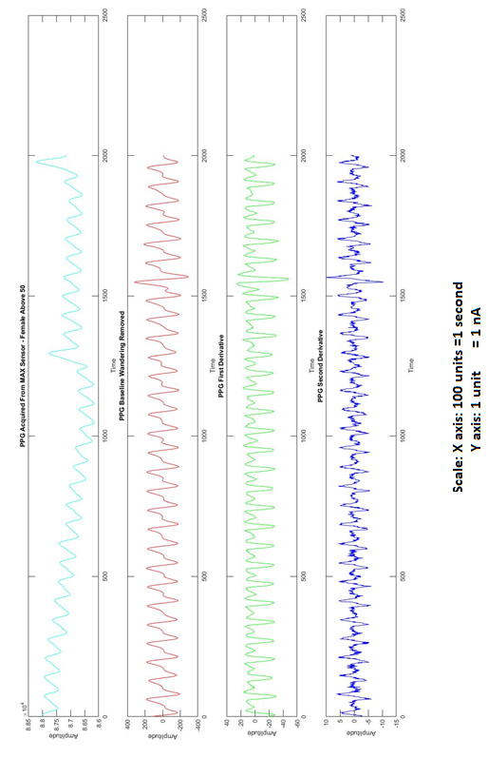

(Figure 4.18: Figure shows plots in green and blue as 1st and 2nd derivative for Female over the age of 50years)

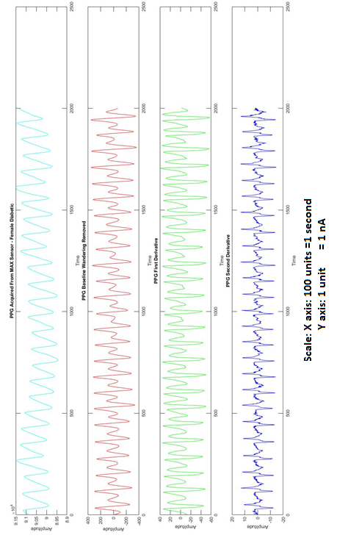

(Figure 4.19: Figure shows plots in green and blue as 1st and 2nd derivative for Diabetic Female)

# 4.3 Analysis and Inference

* Understanding what the parameters signify is important.
* We calculate the parameters for the dataset and compare it with standard values.
* Choosing which parameters work well and which don’t is important.
* The parameters that are able to show a strong correlation for study groups can be used as features for further classification talks.
* We are still in the process of analyzing all the parameters and choosing the best ones.
* From analyzing the ANOVA (Analysis of Variance) and the corresponding t-test we infer that as F<F-critical, the null hypothesis is accepted and we infer that the parameters are not statistically significantly different for men or women. The values obtained from the t-test further help us in accepting the null hypothesis.

# 4.4 Statistical Analysis

We perform the statistical verification of the parameters as shown below in the plots.

Boxplots are a standardized way of displaying the distribution of data based on a five-number summary (“minimum”, first quartile (Q1), median, third quartile (Q3), and “maximum”).

The Boxplots for the important parameters are chosen and plotted to determine outliers as shown.

From the plots, we are able to detect significant outliers in the parameters.

The reason for the algorithm to fail to correctly determine the parameters attributes to incorrectly determined R peaks and short variations in the amplitudes of the diastolic peaks in the signal.

This was confirmed by visually inspecting the signals and checking the results with that of the algorithm.

An approach to solve this problem would be to reject peaks that occur very close to each other and to establish a dynamic threshold to counter the situation of varying amplitudes.

This has been successfully updated to the algorithm, however the results for all the data are yet to be calculated.

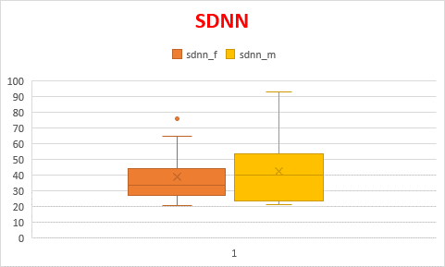

(Figure 4.20)

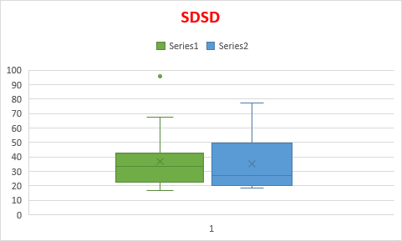

(Figure 4.21)

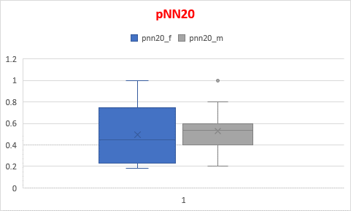

(Figure 4.22)

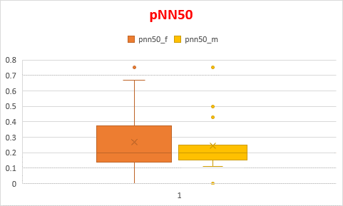

(Figure 4.23)

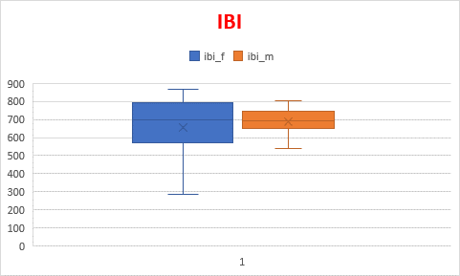

(Figure 4.24)

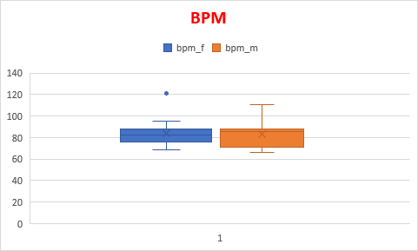

(Figure 4.25)

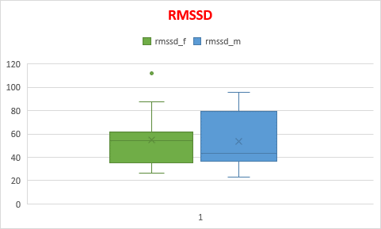

(Figure 4.26)

# Anova

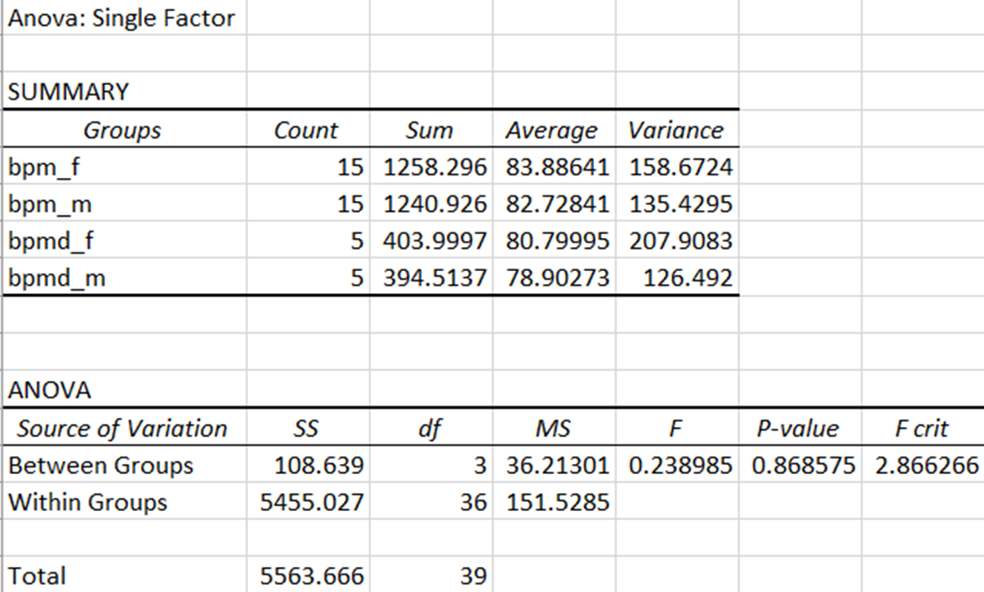

(Figure 4.27.1: Anova for BPM)

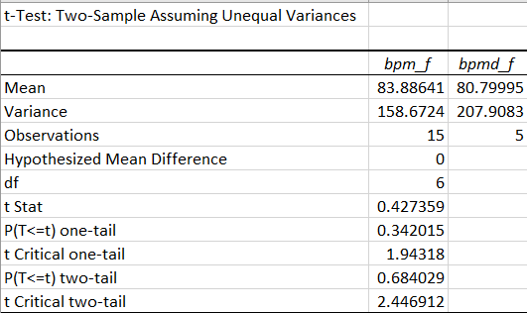

(Figure 4.27.2: T Test BPM)

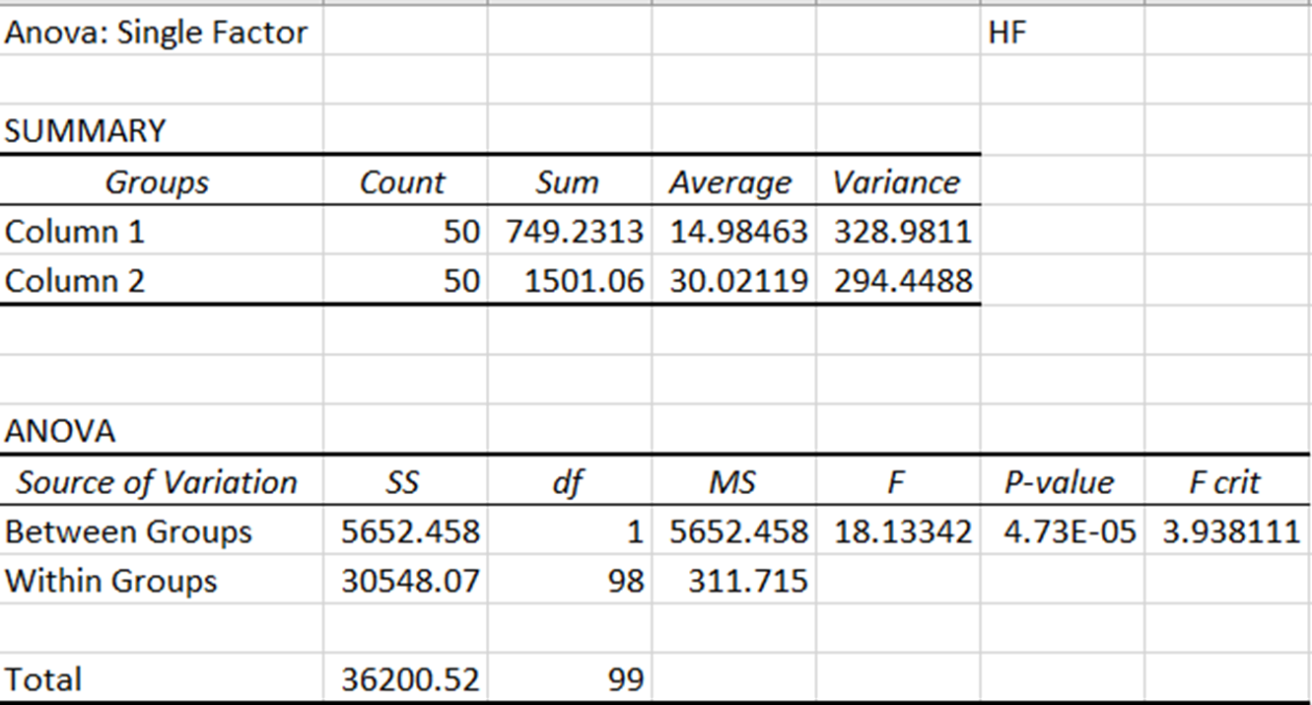

(Figure 4.28: Anova for HF)

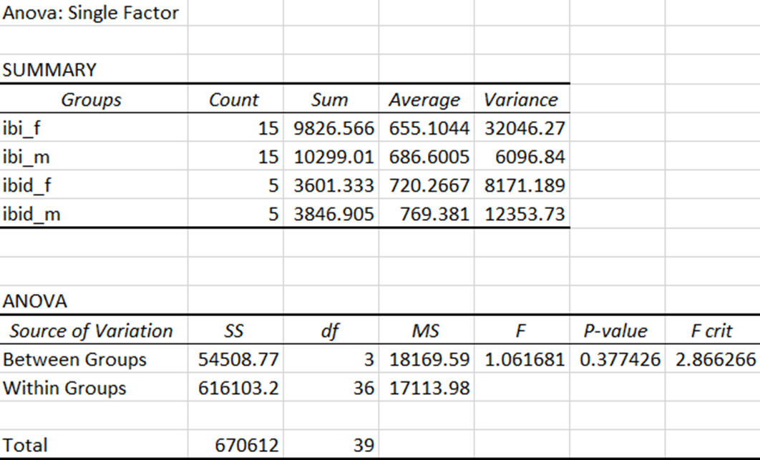

(Figure 4.29.1: Anova for IBI)

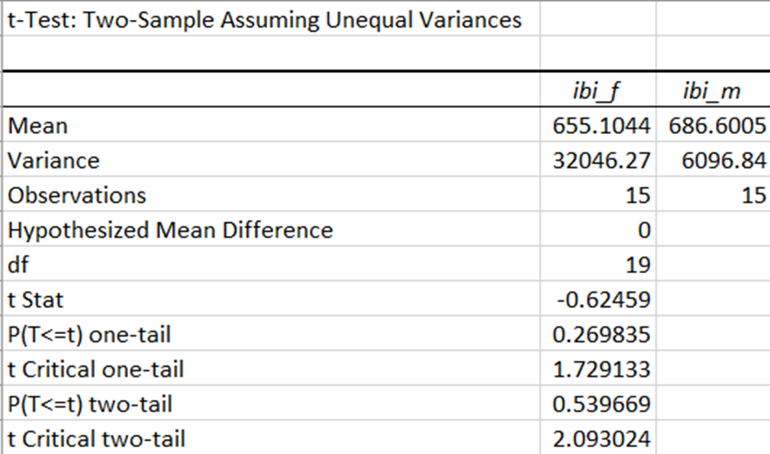

(Figure 4.29.2: T Test for IBI)

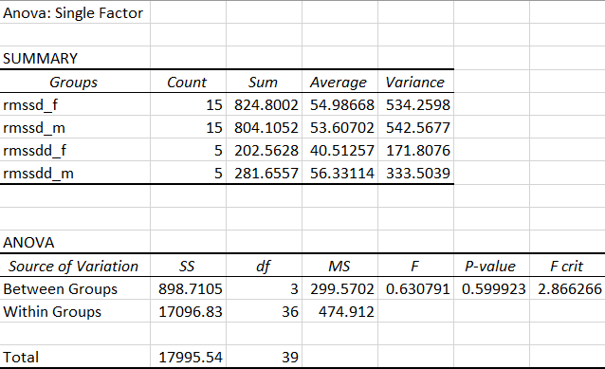

(Figure 4.30.1: Anova for RMSSD)

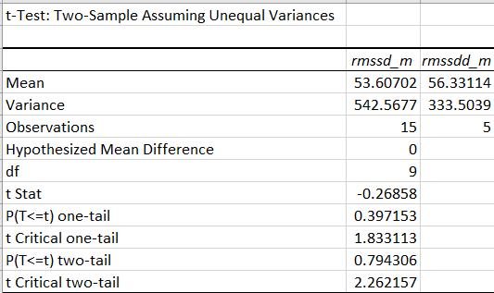

(Figure 4.30.2: T Test RMSSD)

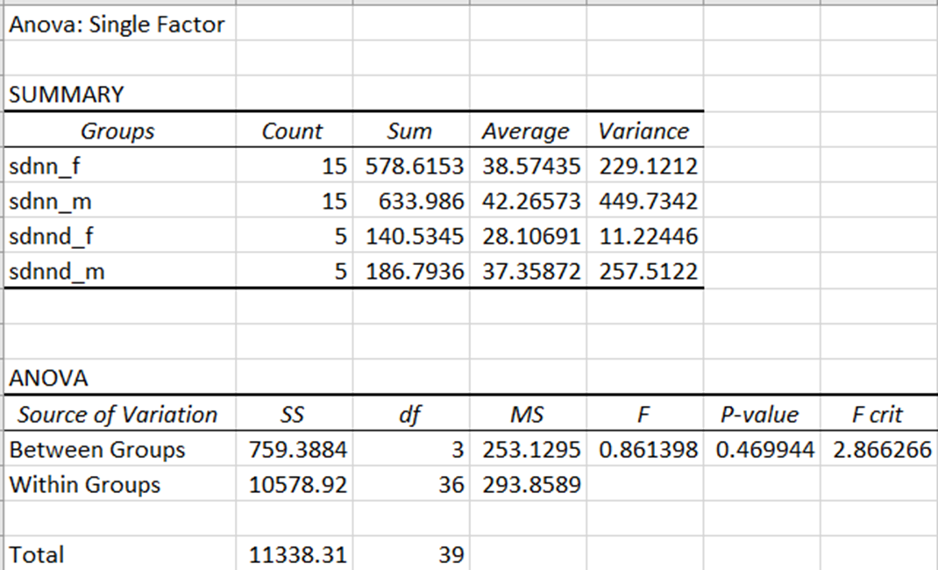

(Figure 4.31.1: Anova for SDNN)

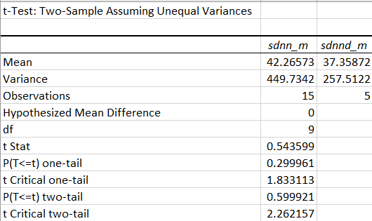

(Figure 4.31.2: T Test SDNN)

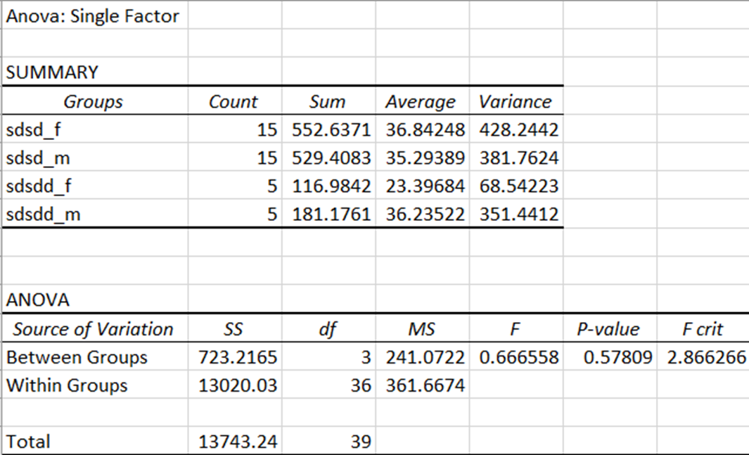

(Figure 4.32.1: Anova for SDSD)

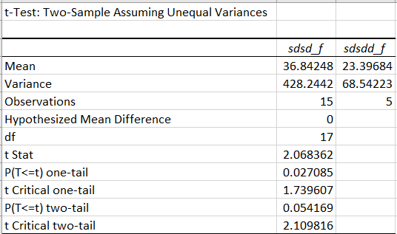

(Figure 4.32.2: T Test SDSD)

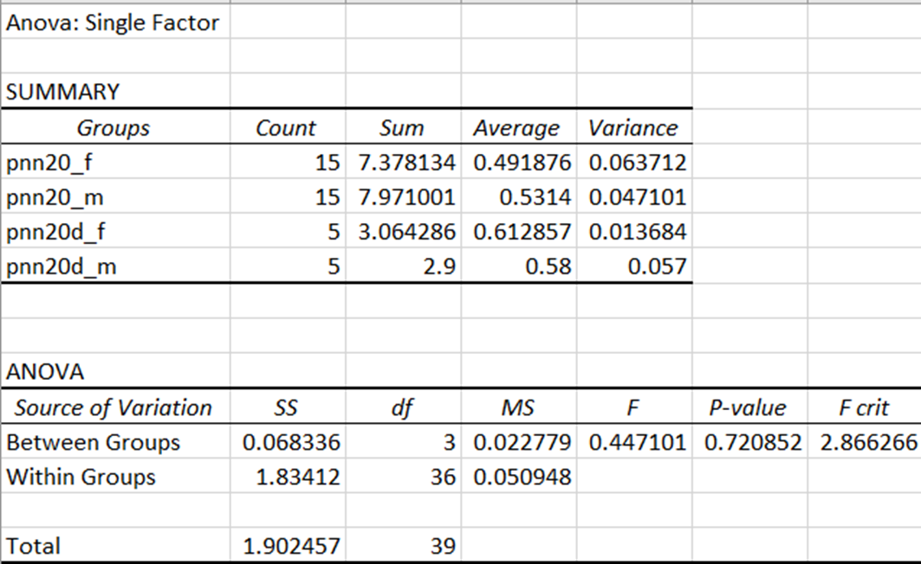

(Figure 4.33.1: Anova for PNN20)

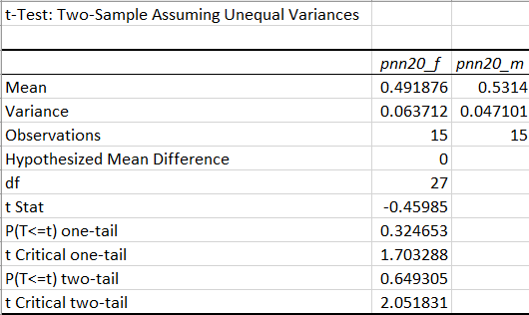

(Figure 4.33.2: T Test for PNN20)

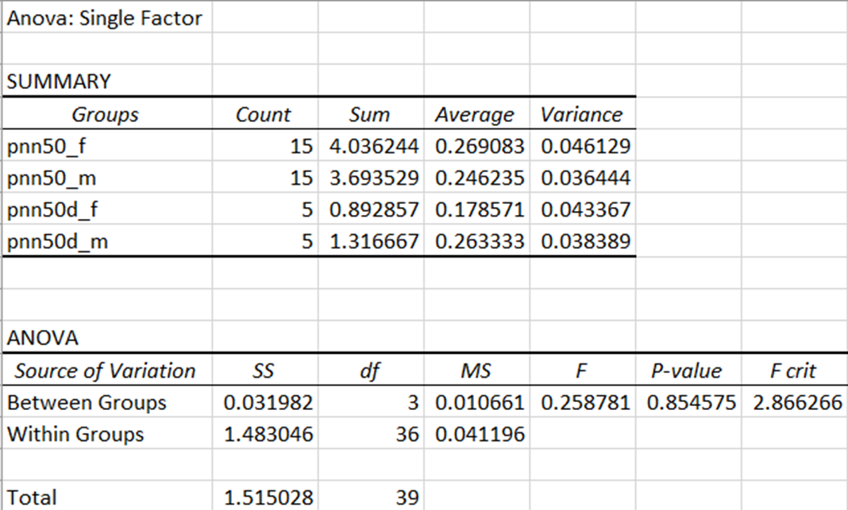

(Figure 4.34.1: Anova for PNN50)

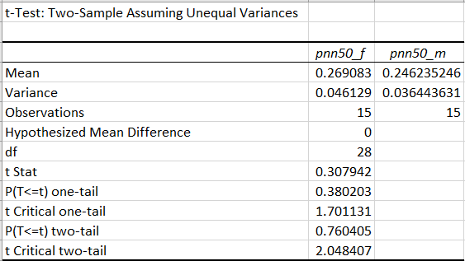

(Figure 4.34.2: T Test for PNN50)

# Chapter 5

**Conclusion, Future work and References**

# 5.1 Conclusion and Future Works

In this report we have described our efforts to create an end to end paradigm for the acquisition, collection and analysis of PPG signals. The motivation to develop such a system was that what is available as hardware and software is often highly technical and too expensive to implement or has very less scientific documentation.

While there are various sensors available in the market for acquiring PPG and pulse oximetry, they either come as kits which need assembling and are very fragile or they come as a PDA + Sensor system but they are too expensive. Hence there needs to be a middle ground for cost effective and accurate solution to aid in the study of PPG signals.

It is for this reason that the main objective of the enclosure design was to ease in the acquisition of the signal by providing mechanical support to the sensor and microcontroller kit and prevent it from stress damage.

The current avenues in acquisition of PPG signals is usually from the fingertips, however carotid and wrist also give highly accurate signals which is well documented. Keeping this in mind the enclosure was designed to allow acquiring of signals from carotid, wrist, fingertip as well.

The signals collected form the 204 volunteers are stored as a database for future reference.

Additionally, we have designed an algorithm to calculate HRV (Heart rate variability) parameters and extract the features from the PPG signals. The motivation behind this is that while there are software available that calculate HRV parameters, they are either too expensive (Kubios software) or not available to everyone for use. Few of them are proprietary to the manufacturer of the sensor (Biopac systems - AcqKnowledge).

The algorithm is designed in Python to facilitate scalability when offloading to low cost microprocessors. The structure of the algorithm is designed to automate the process of pre-processing the signal to make it suitable for analysis & calculating the HRV parameters thereafter while giving the user sufficient scope for changing the input parameters as required as per his/her requirement.

In conclusion, we have been able to successfully implement a suitable design for the MAX sensor and use it to collect a database of PPG signals from various volunteers and also design and implement an algorithm for calculating the HRV parameters for feature extraction.

We acknowledge that this is not the end and there is still scope for further improvement in all domains.

Starting with the sensor and enclosure, the current design can be scaled up to become a wearable PPG sensor with wireless connectivity. There are various wearable sensors available in the market such as Biopac-Bionomadix as well as fit bits & smart watches that provide onboard PPG and ECG sensors as well.

From the data perspective, we can aim at increasing the sample size of the volunteer base. This will allow us to use the data for more data intensive applications like Deep Learning.

From the signal processing perspective, we seek to increase the robustness of the algorithm to noise and data from different sources. The HRV analysis is very sensitive to outliers and marking of peaks on anomalous positions affect these measures as they rely on the intervals between the peaks. We want to document where the algorithm fails so that it becomes easy to resolve the problem.

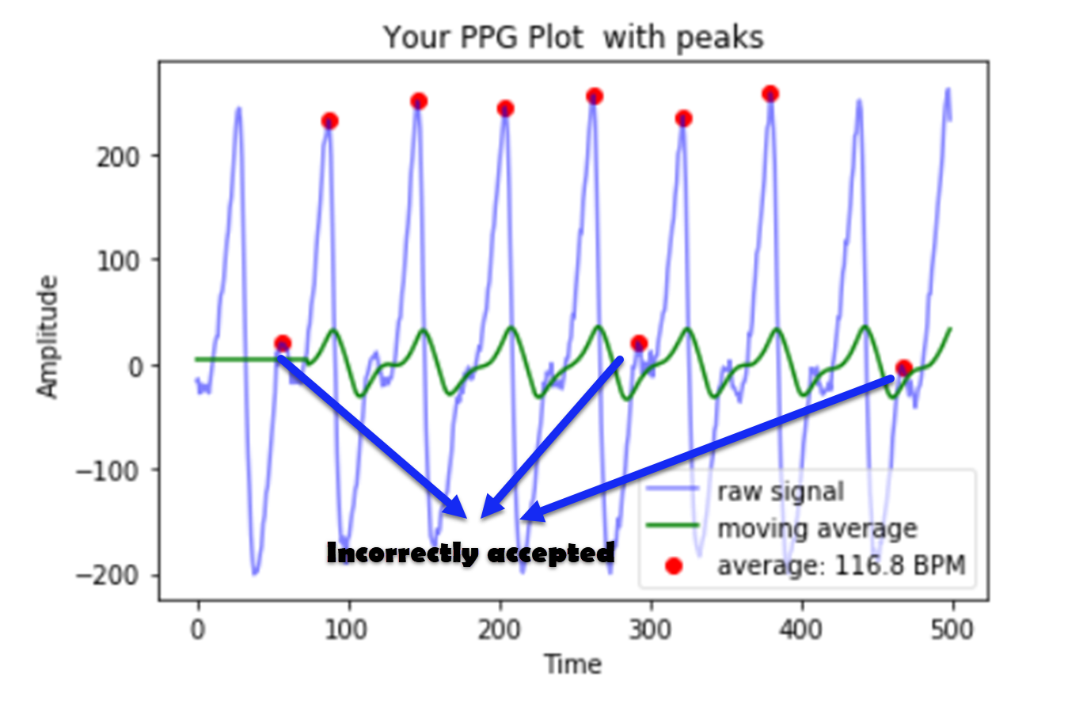

(Figure 5.1: *Figure shows the incorectly labelled peaks where no R peak is present*)

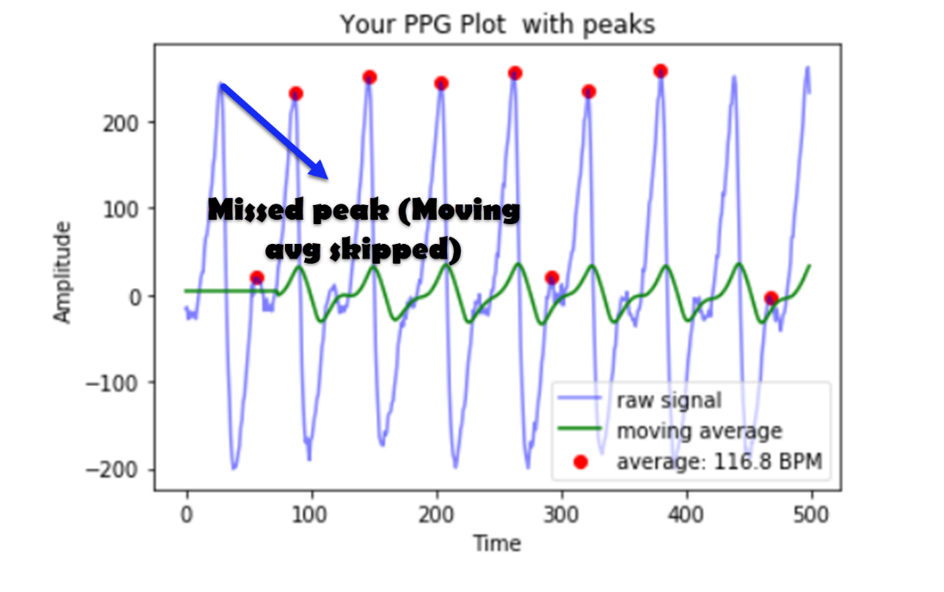

(Figure5.2: Figure shows missed peaks where peak is present but not accepted by the algorithm)

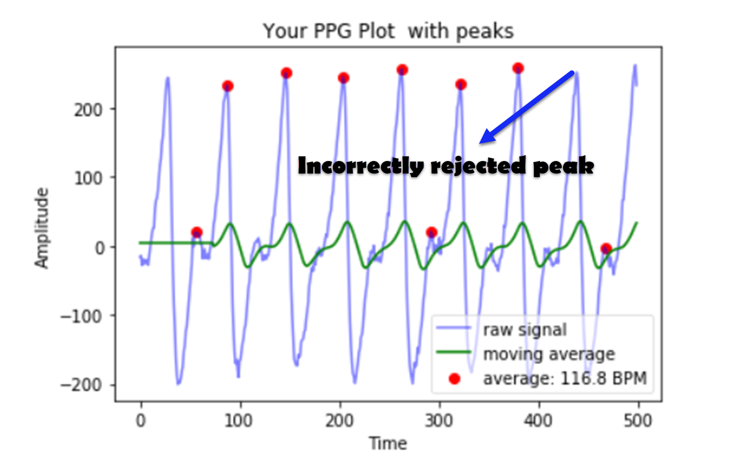

(Figure 5.3: *Figure shows incorrectly rejected peaks i.e. a peak that is marked due to low confidence or going out of bounds of the threshold limit*)

# 5.2 References:

1. Elgendi M. On the analysis of fingertip photoplethysmogram signals. Curr Cardiol Rev. 2012;8(1):14–25. doi:10.2174/157340312801215782
2. Cheang P, Smith P. An overview of non-contact photoplethysmography. Electronic Systems and Control Division Research, Dept Electron and Elect Eng, Loughborough Univ UK. 2003. pp. 57–9.
3. Zhilin Zhang, Zhouyue Pi, Benyuan Liu, ‘‘TROIKA: A General Framework for Heart Rate Monitoring Using Wrist-Type Photoplethysmographic Signals During Intensive Physical Exercise,’’IEEE Trans. on Biomedical Engineering, vol. 62, no. 2, pp. 522-531, February 2015.
4. Alqaraawi A, Alwosheel A, Alasaad A. Heart rate variability estimation in photoplethysmography signals using Bayesian learning approach. Healthc Technol Lett. 2016;3(2):136–142. Published 2016 Jun 13. doi:10.1049/htl.2016.0006
5. V. Jeyhani, S. Mahdiani, M. Peltokangas and A. Vehkaoja, "Comparison of HRV parameters derived from photoplethysmography and electrocardiography signals," 2015 37th Annual International Conference of the IEEE Engineering in Medicine and Biology Society (EMBC), Milan, 2015, pp. 5952-5955.
6. N. Pinheiro et al., "Can PPG be used for HRV analysis?," 2016 38th Annual International Conference of the IEEE Engineering in Medicine and Biology Society (EMBC), Orlando, FL, 2016, pp. 2945-2949.doi: 10.1109/EMBC.2016.7591347
7. van Gent, P. (2016). Analyzing a Discrete Heart Rate Signal Using Python. A tech blog about fun things with Python and embedded electronics.
8. Shaffer F, Ginsberg JP. An Overview of Heart Rate Variability Metrics and Norms. Front Public Health. 2017;5:258. Published 2017 Sep 28. doi:10.3389/fpubh.2017.00258
9. McCraty R, Shaffer F. Heart rate variability: new perspectives on physiological mechanisms, assessment of self-regulatory capacity, and health risk. Glob Adv Health Med (2015) 4:46–61.10.7453/gahmj.2014.073
10. Kuusela T. Methodological aspects of heart rate variability analysis. In: Kamath MV, Watanabe MA, Upton ARM, editors. , editors. Heart Rate Variability (HRV) Signal Analysis. Boca Raton, FL: CRC Press; (2013). p. 9–42.
11. Tortora GJ, Derrickson BH. Principles of Anatomy and Physiology. 15th ed New York: John Wiley and Sons, Inc; (2017)
12. Nunan D, Sandercock GRH, Brodie DA. A quantitative systematic review of normal values for short-term heart rate variability in healthy adults. Pacing Clin Electrophysiol (2010) 33:1407–17.10.1111/j.1540-8159.2010.02841.x
13. Billman GE, Huikuri HV, Sacha J, Trimmel K. An introduction to heart rate variability: methodological considerations and clinical applications. Front Physiol (2015) 6:55.10.3389/fphys.2015.00055
14. Lehrer PM, Vaschillo E. The future of heart rate variability biofeedback. Biofeedback (2008) 36:11–4.
15. Baek HJ, Cho CH, Cho J, Woo JM. Reliability of ultra-short-term analysis as a surrogate of standard 5-min analysis of heart rate variability. Telemed J E Health (2015) 21:404–14.10.1089/tmj.2014.0104
16. Umetani K, Singer DH, McCraty R, Atkinson M. Twenty-four hour time domain heart rate variability and heart rate: relations to age and gender over nine decades. J Am Coll Cardiol (1998) 31:593–601.10.1016/S0735-1097(97)00554-8